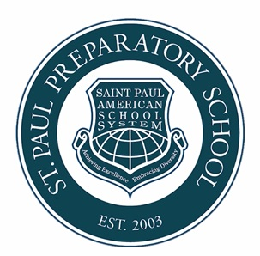
Saint Paul Prep Online
20 Sourwood Court, Youngsville, NC, USA
spass.international/spps1/
admissions@SPPOnline.onmicrosoft.com

Welcome to Saint Paul Preparatory School Online. This school is a part of the Nacel School System, est. 2003. Currently, Nacel host multiple campuses Korea, China, Vietnam, and The Philippines. Our virtual campus hosts the same high-quality education and allows for greater access to students unable to attend one of our on campus locations.
Saint Pauls core teachers are from the United States and non-English language teachers are from China and Spain along with some highly qualified local teachers. Saint Paul teachers are licensed or have M.A. degrees for the subjects they teach as well as other teaching credentials. For more info, please check spass.international.edu

GENERAL REQUIREMENTS FOR ENROLLMENT:

- Report Card (previous two years)
- 1 photo with white background, without eyeglasses
- Scanned/colored copy of passport
- Student Information Form
- Refund Policy Form

STEPS FOR ADMISSIONS:

- Submit all requirements.
- Submit filled out student information form.
- Submit the signed refund policy form.
- Pay tuition and fees (as discussed and agreed during your inquiry).

